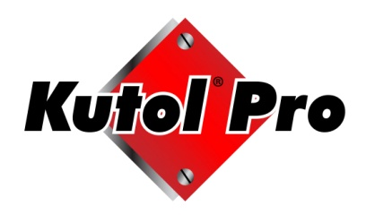

Kutol Pro Try & Buy Promotion Planning & Reimbursement Form

Distributor/Installer Information
Distributor Name:
Contact Name: |  |  |  |  |  |  |  |  |  | Installer Name:
Address:
Promotion Dates: |  | through |  |  |  |  |  |  |  | (90 days max, unless pre-authorized by Kutol)
Kutol Sales Rep: |  |  |  |  |  |  |  | Rep. Company Name:
Proposed Sales Meeting Date: |  |  |  | # of DSR’s: |  |  |  | Samples/Literature Ordered: Yes No |  |  |  |  |  |  |  |  |  | Date:

Targeted End Users
End User Name: |  |  |  |  |  |  |  |  | Kit Item #: |  |  |  |  |  | No. of Kits:
 |  |  |  |  |  |  |  |  | Total:

KUTOL SIGNATURE FOR PROMOTION APPROVAL
Kutol Signature |  |  |  |  |  |  |  | Date
HANGING ALLOWANCE REIMBURSEMENT
Kutol will pay $12.00 per Kutol Pro DuraView 2 liter Kit (16DV2, 23DV2, 45DV2, 47DV2, 49DV2, 52DV2 & 77Dv2). Limit 2 per End User.

At the conclusion of the promotion, submit this form and copy of the invoice from Distributor to the End User as Proof of Delivery (POD) to Kutol within 30 days from promo expiration date for credit memo. POD must accompany this form.
Total # of Kits: |  |  |  |  | X | $ 12.00 |  |  |  |  | Total Amount to be Paid:
Rep. Signature (for Credit Memo approval) |  |  |  |  |  |  |  | Date
FOR INTERNAL USE

Approved for payment at Kutol by: |  |  |  |  |  |  |  |  |  |  |  |  |  | Date

