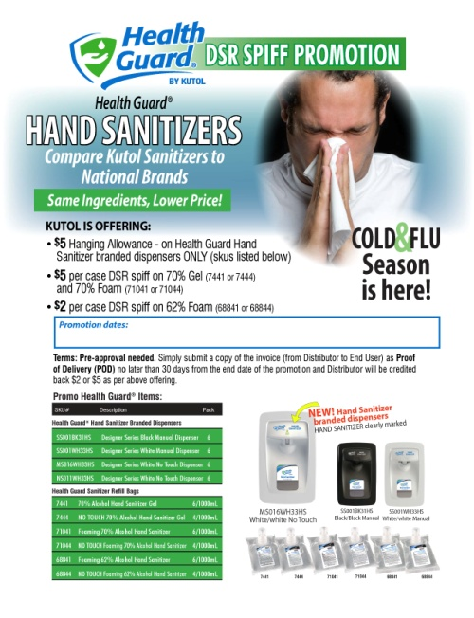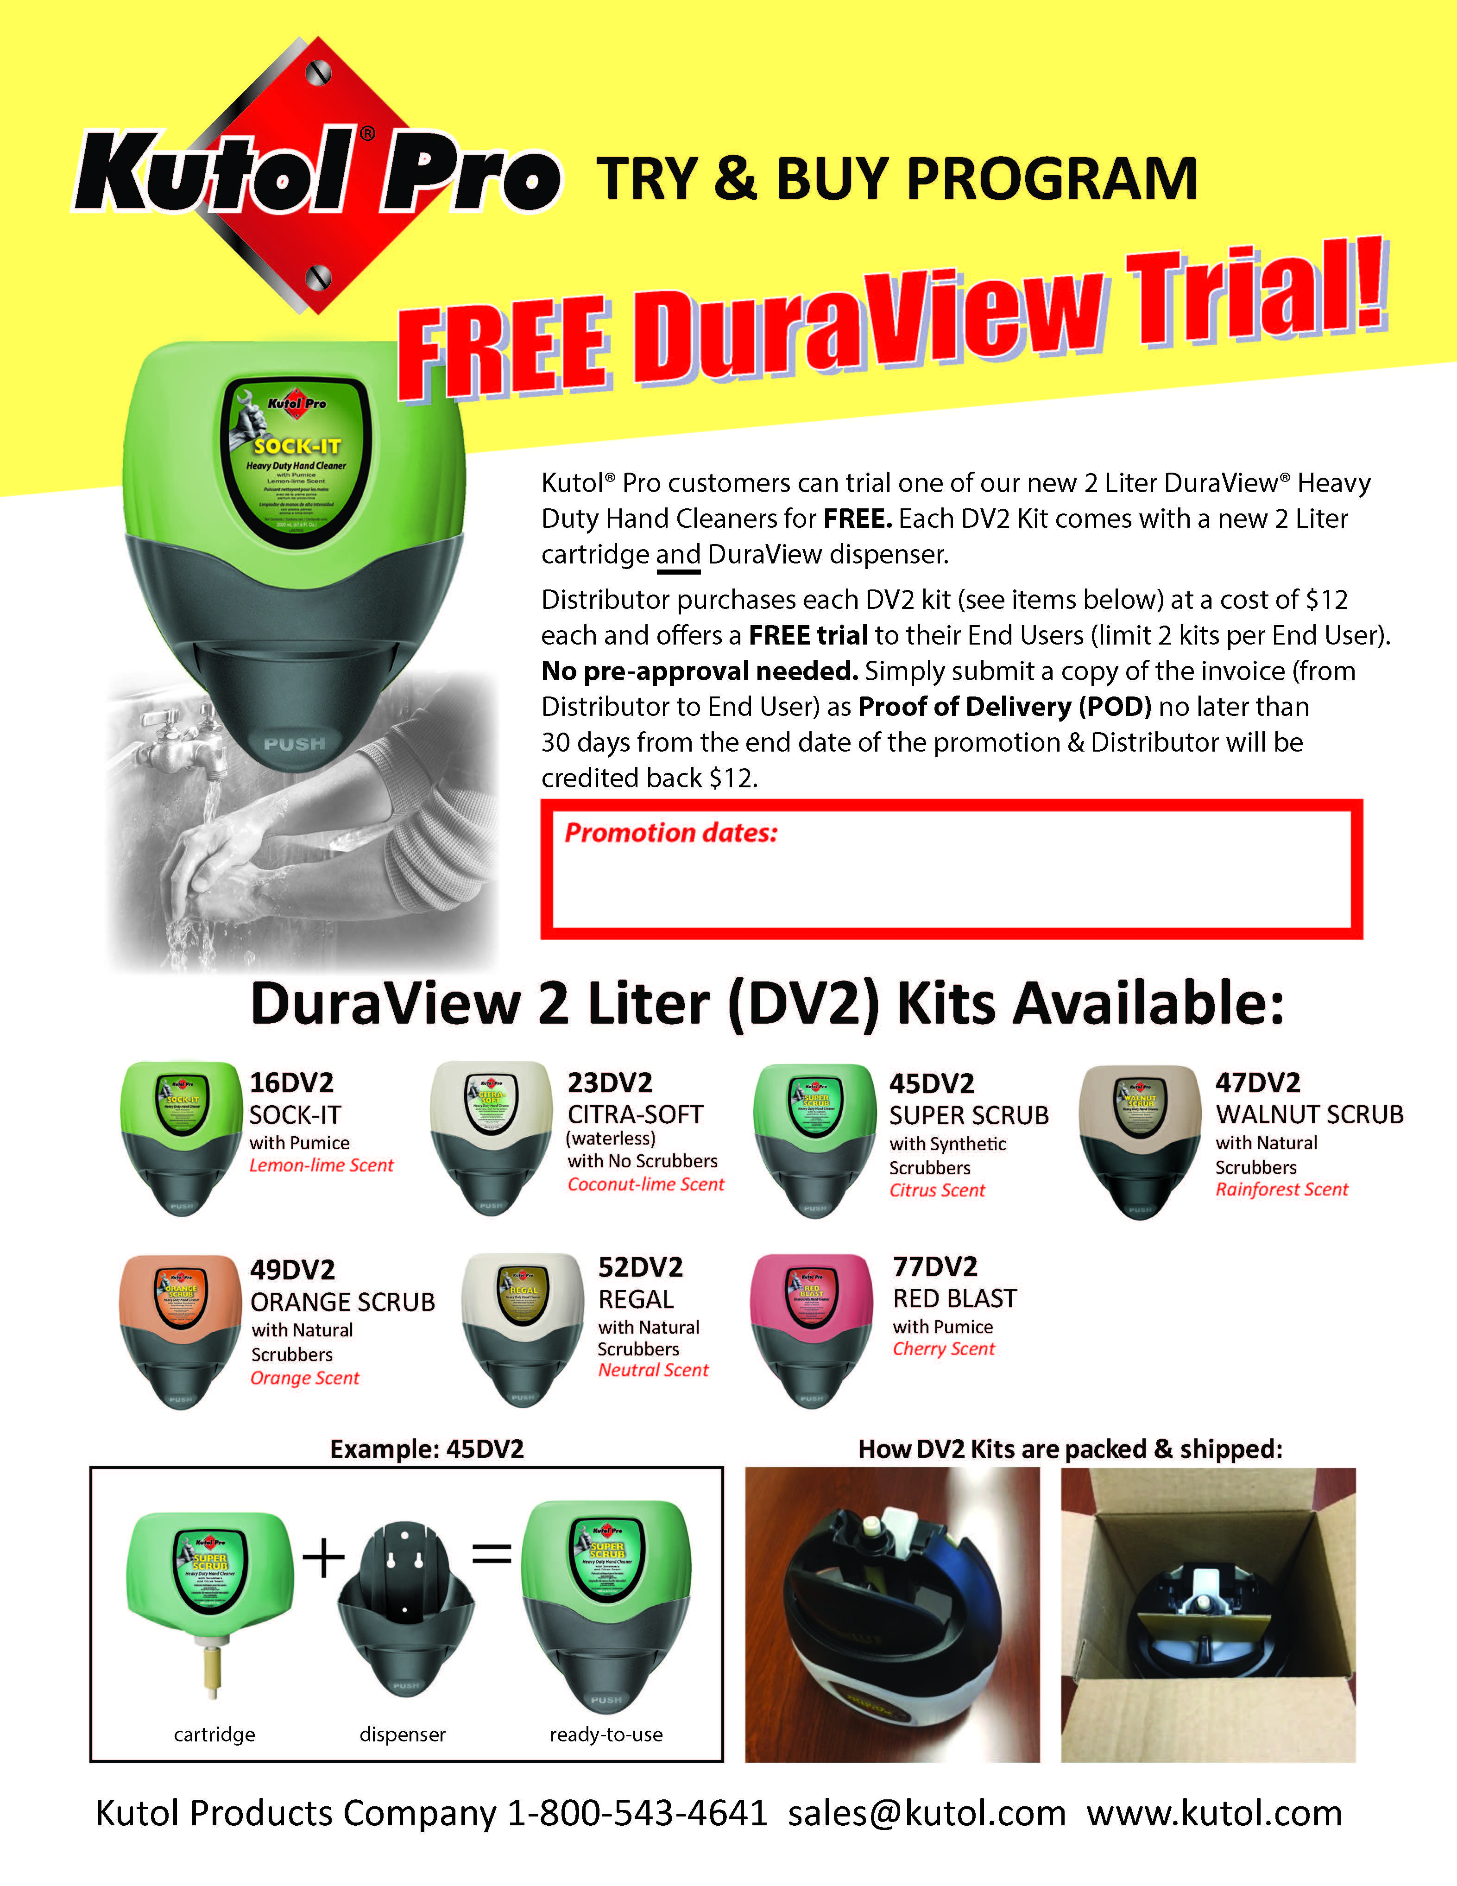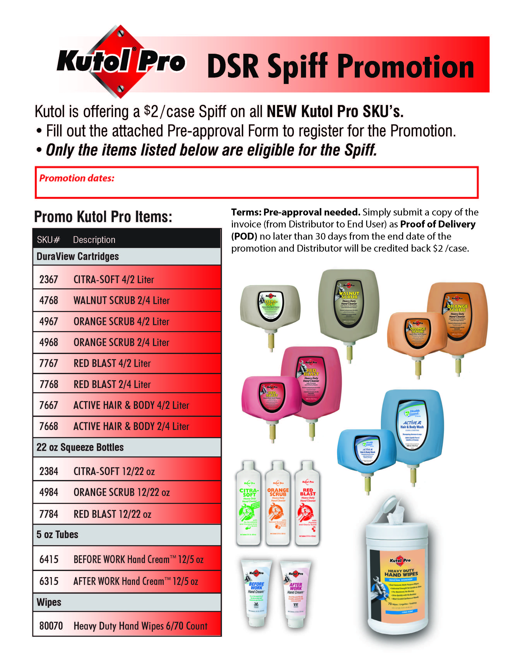**Kutol 2019 Promotion Options**

**Health Guard® Hand Sanitizer DSR Spiff Promotion**

**Kutol® Pro DSR Spiff  
Promotion**

**Try n Buy Promotion (DuraView)**

Kutol is pleased to offer the following promotion options for the 2019 calendar year to our strategic distribution partners.

Requirements:

* 1 promo per 90-day period with pre-approval (required in advance, submitted to tbasham@kutol.com). **Promotion dates must be included with pre-approval form.**
* POD submission required no later than 30 days from the close of the promotion date.